# Step 1: Define the ItemToPurchase class with appropriate attributes and methods
class ItemToPurchase:
def __init__(self):
self.item_name = "none"
self.item_price = 0
self.item_quantity = 0

def print_item_cost(self):
total_cost = self.item_price * self.item_quantity
print(f"{self.item_name} {self.item_quantity} @ ${self.item_price:.2f} = ${total_cost:.2f}")

# Step 2: Create two instances of ItemToPurchase and gather user input
if __name__ == "__main__":

item1 = ItemToPurchase()
item2 = ItemToPurchase()

print("Item 1")
item1.item_name = input("Enter the item name: ")
item1.item_price = float(input("Enter the item price: "))
item1.item_quantity = int(input("Enter the item quantity: "))

print("\nItem 2")
item2.item_name = input("Enter the item name: ")
item2.item_price = float(input("Enter the item price: "))
item2.item_quantity = int(input("Enter the item quantity: "))

# Step 3: Print the total cost for each item and the overall total
print("\nTOTAL COST")
item1.print_item_cost()
item2.print_item_cost()

total = (item1.item_price * item1.item_quantity) + (item2.item_price * item2.item_quantity)
print(f"Total: ${total:.2f}")

Output:
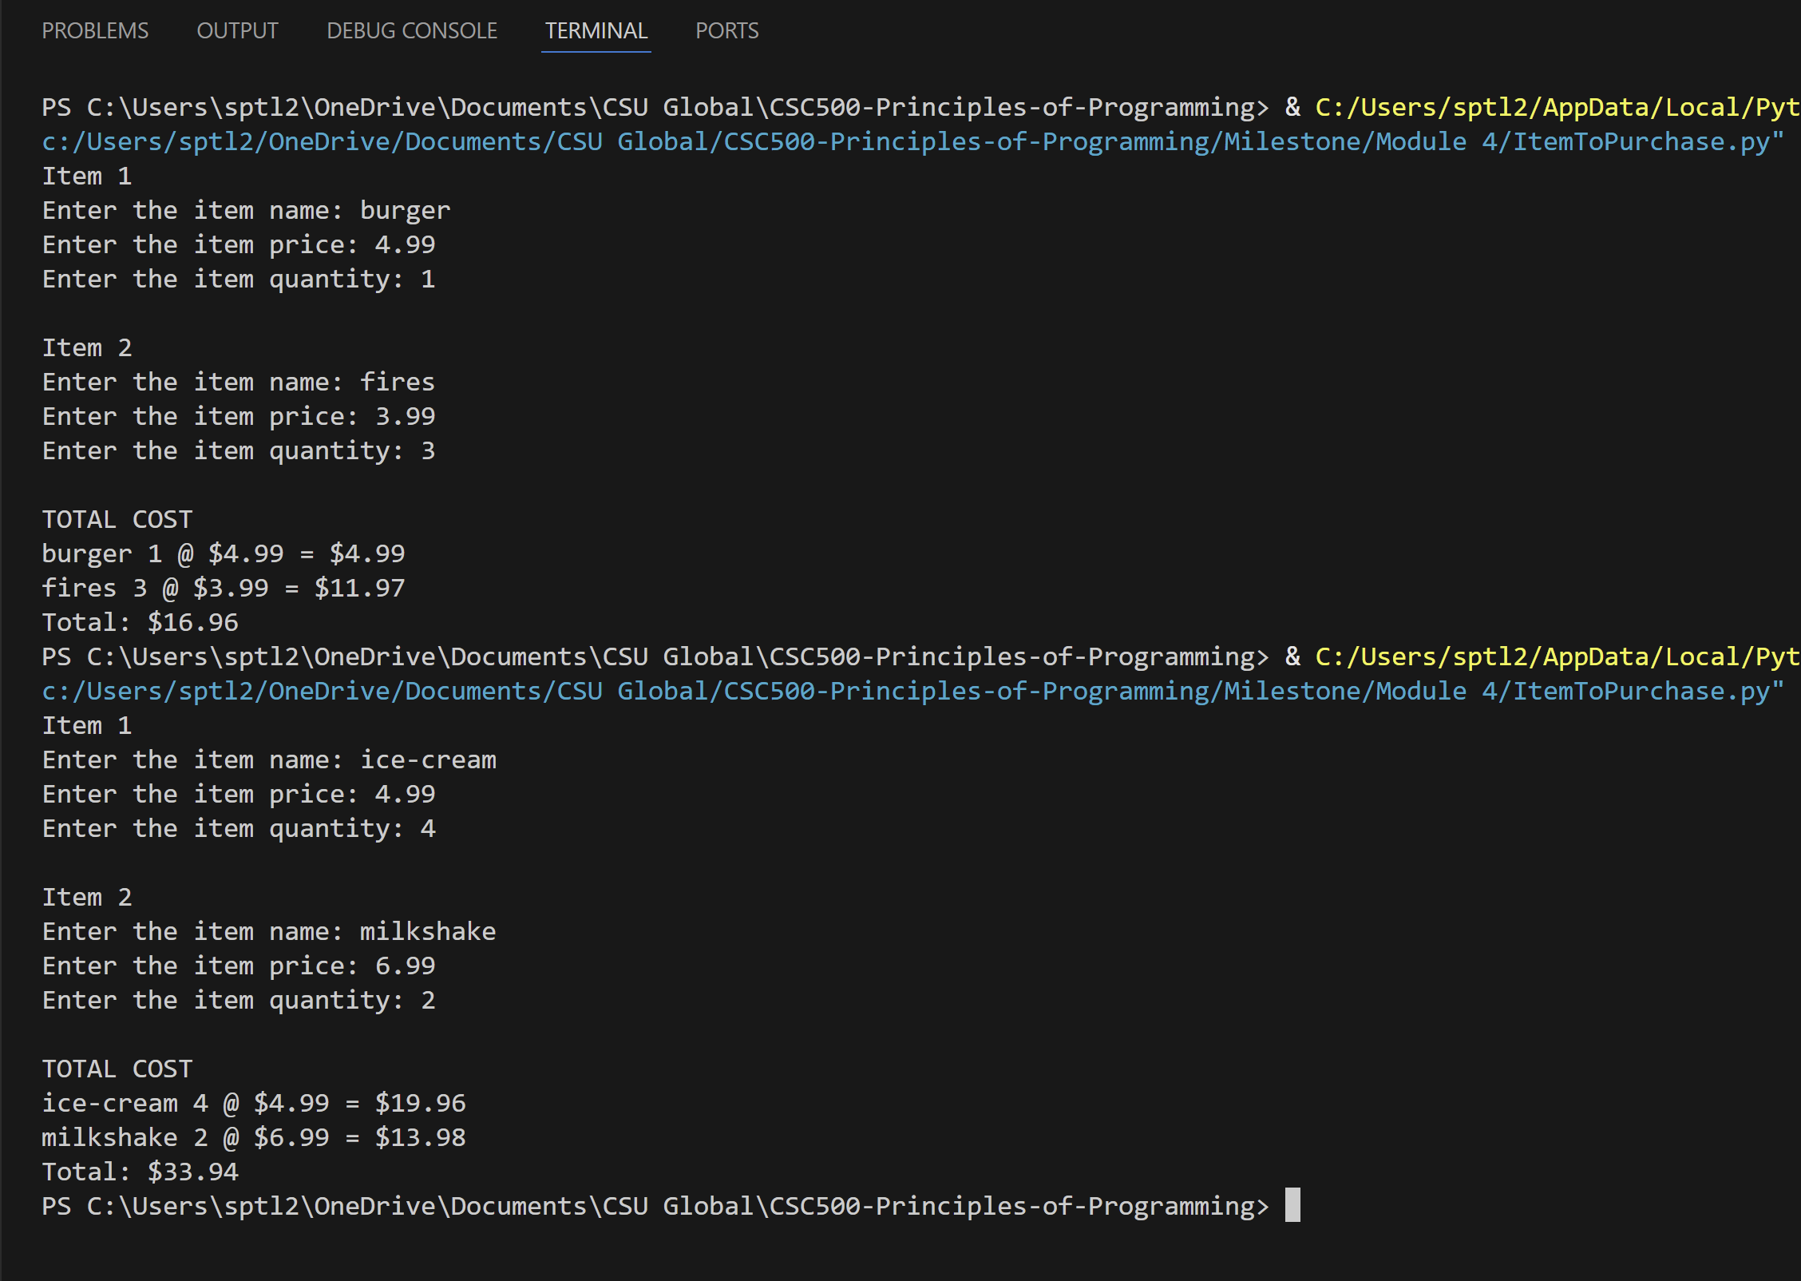

Github Link : ItemToPurchase.py

